Report

Frontpage (Cover page)

Abstract

Table of content

Introduction

Key Features

Entity-relationship diagram

Relational database

Relational schema

Screenshots (according to the features)

Advantage

Disadvantage

Future work

Conclusion

References

**Introduction:**

In early 2020, after a December 2019 outbreak in China, the World Health Organization identified SARS-CoV-2 as a new type of coronavirus. It was first detected in Wuhan. Within a few months the outbreak spread quickly around the world. Approximately 219 countries are affected by the coronavirus. Later on, WHO declared it as a pandemic on March 11. Coronavirus comes with some symptoms like respiratory illness presented as a flu-like illness. Fever, cough, myalgia, and fatigue are the commonest symptoms. Other features include dyspnea, headache, malaise, non-specific gastrointestinal (GI) symptoms such as abdominal pain, nausea, diarrhea. It spread so quickly that now the total number of coronavirus cases is 119M, the total death is 2.63M, and the total recovered cases are 67.3M globally. On March 7, 2020 Bangladesh confirmed their first case. After that Bangladesh took some steps to fight with COVID-19. Like lockdown, wearing masks, hand washing, providing information, call services, online services, covid test, clustering, and so on according to WHO. The total number of affected, death and recovered cases in Bangladesh is 554K, 8,502, and 508K. By analyzing the data. it is well known that Bangladesh is handling the situation of COVID-19 surprisingly very well. Our goal to work with the data of COVID-19 and categories them based on different behavior. So that we can visualize them and can take action according to the data. Our Project Covered most of the scenarios that a user may be willing to know about COVID Situations, Questions like, How many are Dead? Which age people are being affected so much? When they should test COVID-19?  etc. It is our vision to create awareness among people with information.

**Key-Features:**

* Users Can Get Current Information about COVID-19 like (Total Number of Cases of ):

* Calls.
* Tests.
* Positive && Negative Cases.
* Deaths.
* Released Patients.
* Serious Patients.
* Male and Female.
* Bangladeshi and Foreigner Patients.

* User can have the information about aged based Total Cases Like:

* Children
* Teens
* Adults
* Older Adults

* Users Can See The Amount of Affected Division Wise.
* Users Can See The Amount of Affected People Occupation Wise.
* We Have The Track of Monthly Positive Cases of a year.
* Callers Can Have the Suggestion Based on Their Given Symptoms.
* Authorized Person Can see the Details of Released, Death and Serious Patients list.

**Advantages:**

* Common People can have the Update about COVID-19 Situation.
* We transfigure all our queries with different view tables so that it can be an automated system along with the abstractions.
* Users don’t have to query again and again for knowing the total number of different cases like positive, negative, male, female and death etc from different tables so we merge all the scenarios with one table so that users can have all things at a time.
* We build a system based on users' symptoms which guide users whether they should test COVID-19 or not.
* We classified age, Division, and Occupations based Positive Cases so that users have the clear understanding and can take actions according to data. like if the positive case of dhaka division is higher then users can take decision to go for lockdown and so on.
* We tried to build this project with a few main tables so that users never feel that our system is so complex.
* Vaccination Programs can use our COVID-19 information management system to successfully run the Campaign.
* In Future if COVID-19 again appears, then our COVID-19 information management system will give some idea to researchers what to do or what not to do.

**Disadvantages:**

* We did not work with some major attributes like, Blood Group, Date of Birth etc.
* We work with few symptoms to determine the user’s condition but in real time covid symptoms are many so it could be misleading sometimes.
* As we use the view table to show our features, each one has their functional dependency so if any table somehow gets dumped then our whole system will crash.
* We classified Monthly cases into a year table. so for every year we again need to create a table to show monthly cases. So, users need to hire developers for it.
* We did not work with Home Quarantine Positive case patients.
* We did not work on the Kit survey.

**Future-Work:**

* We will work with particular areas like Dhanmondi, Gulshan , mohammadpur etc.
* We will increase symptoms in our project so that the ratio of correctness of the suggestion will be higher.
* We will work with the date of birth and Blood group.
* We will work for other gender people also.
* Our project can be used in Different Government sectors.
* We will connect our Project with Front end and will bring it to live so that common people can take advantage of our project.
* We will connect our database with the Vaccine management system.
* We will add a PPI calculation entity.
* We will count the amount of kit being used and the amount of kit we have stored.

**Conclusion:**

In Situation like now, Surely Bangladeshi peoples need awareness. Our Project will play a significant role in this scenario. Though we didn’t cover all of the scenarios, we covered a significant one. We tried to simplify our project as much as Possible so that the user doesn't feel complex when working with our database.We hope it will help Common people as well as our government.

**Relational Schema**

**Caller_Info ( Serial_Number, Caller_Name, Caller_Area, Caller_Division, Caller_Phone,_No, Date_of_call, Symptoms, Body_Temperature(F))**

**Suggestion ( Serial_Number, Caller_Name,  Caller_Phone_no, Suggestion)**

**Test_Report (Kit_id, Tester_Name, Tester_Gender, Tester_Age, Test_Date, Tester_Phone_Number, Tester_Occupation, Tester_Address, Tester_Division, Test_Result, Tester_Tester_Results, Tester_Religion)**

**Affected_People ( Kit_id, Name, Gender, Age, Phone, Occupation, Address, Division, Religion)**

**Patients ( Patient_id, Kit_id, Admitted_Date, Patient_Progess, Patient_ Status, Releasd_Date)**

**Death ( Patient_id, Name, gender, Age, Phone, Address, Admitted_Date, Date_Of_Death)**

**Released ( Patient_id, Name, Gender, Age, Phone, Address, Admetted_Date, Released_Date)**

**Serious_Patients ( Patients_id, Name, Gender, Age, Phone, Admitted_Date)**

**E R Diagram: Link.** <https://miro.com/app/board/o9J_lOC9Xh8=/>

**Relational Database :**

|  |
| --- |
| **Caller_Info** |
| **Serial_Number** |
| **Caller_Name** |
| **Caller_Area** |
| **Caller_Division** |
| **Caller_Phone,_No,** |
| **Date_of_call** |
| **Symptoms** |
| **Body_Temperature(F)** |

|  |
| --- |
| **Suggestion** |
| **Serial_Number** |
| **Caller_Name** |
| **Caller_Phone_no** |
| **Suggestion** |

|  |
| --- |
| **Affected_People** |
| **Kit_id** |
| **Name** |
| **Gender** |
| **Age** |
| **Phone** |
| **Occupation** |
| **Address** |
| **Division** |
| **Religion** |

|  |
| --- |
| **Test_Report** |
| **Kit_id** |
| **Tester_Name** |
| **Tester_Gender** |
| **Tester_Age** |
| **Test_Date** |
| **Tester_Phone_Number** |
| **Tester_Occupation** |
| **Tester_Address** |
| **Tester_Division** |
| **Test_Result** |
| **Tester_Religion** |

|  |
| --- |
| **Serious_Patients** |
| **Patients_id** |
| **Name** |
| **Gender** |
| **Age** |
| **Admitted_Date** |
| **Phone** |

|  |
| --- |
| **Patients** |
| **Patient_id** |
| **Admitted_Date** |
| **Patient_Progess** |
| **Patient_ Status** |
| **Releasd_Date** |

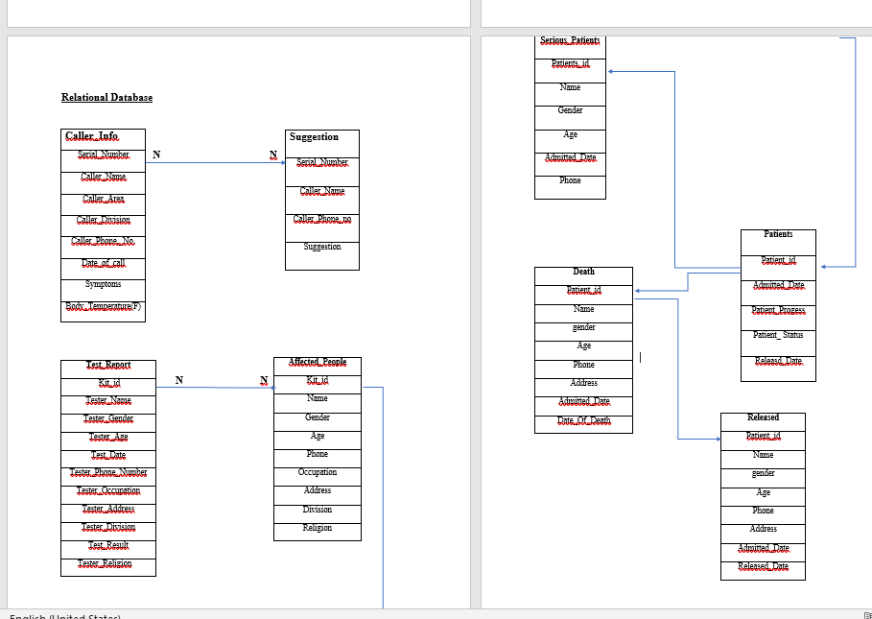

**References:**